PERISCAPULAR STABILIZATION AND STRENGTHENING EXERCISES

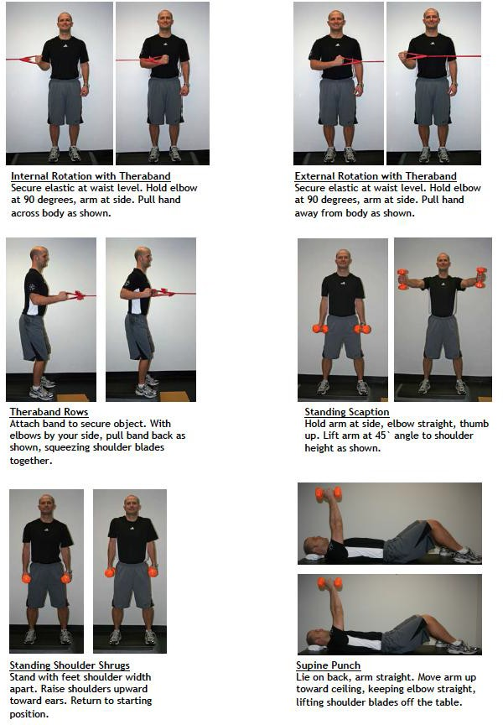

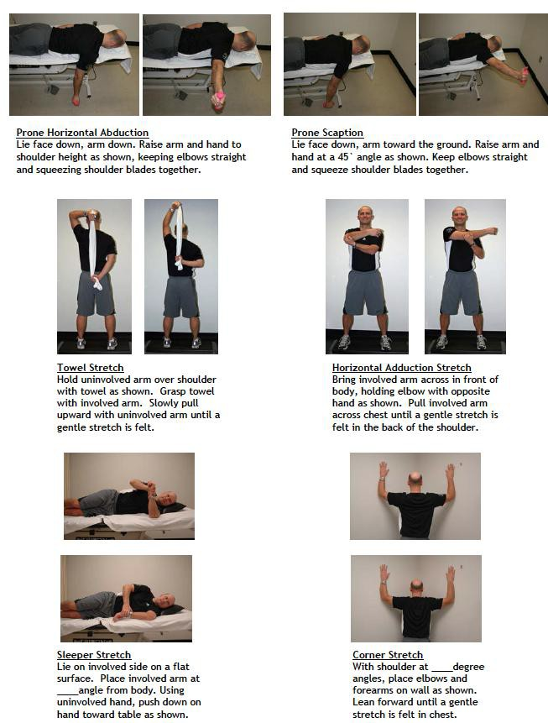

Scapular Retraction Sets

- Scapular hold "Straight"
  - Both hands straight out in front of you
  - Pull shoulders back like you feel your shoulder blades squeezing together
  - Hold for 3 seconds, relax for 3 seconds
  - 10 repetitions
- Scapular hold "T"
  - Begin with scapular hold "Straight"
  - Put arms in a "T" position with arms straight out to your sides while holding shoulder blades squeezed together
  - Hold for 3 seconds, relax for 3 seconds
  - 10 repetitions
- Scapular hold "Y"
  - Begin with scapular hold "Straight"
  - Put arms in a "Y" position up overhead while holding shoulder blades squeezed together
  - Hold for 3 seconds, relax for 3 seconds
  - 10 repetitions
- Scapular hold "I"
  - Begin with scapular hold "Straight"
  - Put arms in a "I" position up overhead while holding shoulder blades squeezed together
  - Hold for 3 seconds, relax for 3 seconds
  - 10 repetitions

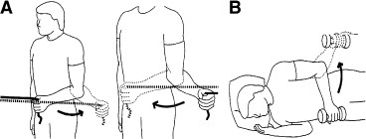
- External and Internal Rotations
  - 10 reps, each arm, 3 sets:

External Rotations:
  - Secure band at waist level
  - Hold elbow at 90°, arm at side
  - Pull hand away from body as shown

Internal Rotations:
  - Secure band at waist level
  - Hold elbow at 90°, arm at side
  - Pull hand across body as shown

External Rotations, laying on your side:
  - Lie on your side, arm at side, elbow bent 90°
  - With or without weight, move hand up as shown

- Inferior Trapezius Pulls
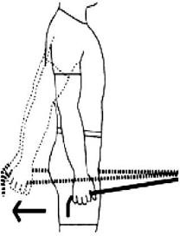
  - Stand upright, shoulder blades squeezed together
  - Grasp elastic bands with both hands
  - Keep elbows straight, pull back as shown, trying to reach behind you
  - 10 reps, 3 sets

